Alaska Educator Evaluation System Student Learning Objective (SLO) Template
Educator’s Name | Jethro Jones |  | School Year | 2016
Grade | 6-8 |  | Subject | All
All information required unless otherwise indicated
Student Population
Which students will be included in this SLO? Attach SLO class roster. |  | Math students in 6-8 grade
Interval of Instruction
What is the duration of the course that the SLO will cover? Include beginning and end dates. |  | - Full Year ❑ Semester ❑ Quarter ❑ Other (please specify):
 |  | Beginning: 10/12/2015 Ending: 02/28/2016
Standard and Content
What content will the SLO target? To what related standards is the SLO aligned? |  | RI 1, RI 2, W3
Assessment and Test Integrity
What assessment(s) will be used to measure student growth for this SLO? |  | Rubric for Annotations & 2 column notes
Why was this assessment selected? |  | To allow all teachers, regardless of content area to be able to consistently provide the instruction and assessment needed to verify success.
How will you administer the assessment(s) securely? |  | All teachers will give it and score it together.
Baseline/Trend Data & Rationale
What information is being used to inform the creation of the SLO and establish the amount of growth that should take place within the instructional interval? |  | Pre-assessment done by ELA teachers in September and October.
If baseline and trend data supports the development of tiered targets, what criteria are being used to group students? On class roster, identify each student’s group placement. |  | Low level of preparedness
 |  | Medium level of preparedness
 |  | High level of preparedness

2014 TLSI Page 17

Growth Target(s)
What is your growth target for your students? |  | On the assessment described above, all students cover by this SLO will increase their score by 1 scale score (i.e., moving from a 2 to a 3). Students who are at a 3 or 4 will then write a summary paragraph based on their 2 column notes.
If baseline and trend data supports the development of tiered targets, indicate your target for each group. |  | On the assessment described above, students whose baseline data indicated that they have the lowest level of preparedness will increase their score by...
 |  | On the assessment described above, students who were determined to have a medium level of preparedness will increase their score by...
 |  | On the assessment described above, students who were determined to have the highest level of preparedness will increase their score by...
How did you arrive at the growth targets for your students? On the SLO class roster, identify each student’s growth target score. |  | Students who can produce 2 column notes at an adequate level can write summaries effectively.
Scoring
Exemplary (4): more  than 85% of students  met their target | Proficient (3): between  65% and 85% of students  met their target |  | Basic (2): between 40%  and 64% of students met  their target | Unsatisfactory (1):  fewer than 40% of  students met their target

2014 TLSI Page 18

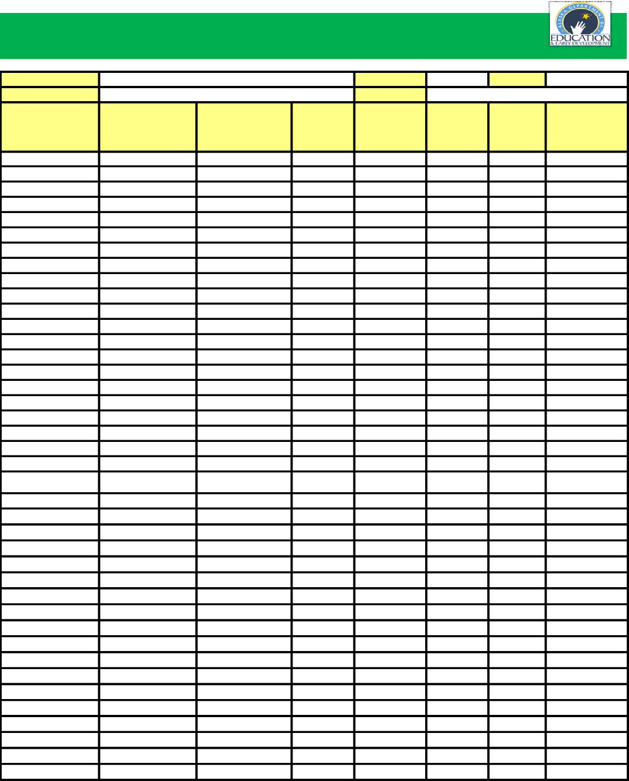
Alaska Educator Evaluation System Student Learning Class Roster
Educator's Name
School Year
1
SLO #
Grade(s)
Subject
Student's Last Name
Student's First Name
Target
Student level of
Preparedness (High,
Medium, Low)
Pre-
Assessment Score
Post-
Assessment
Score
Target
(Met/Not
Met)
Attendance
Threshold
(Met/Not Met)
2014 TLSI Page 19

Purpose: This checklist should be used for assuring the quality of an assessment. In the process, the assessment is checked for Alignment to standards, Stretch, and Validity and Reliability.
Alaska Educator Evaluation System Assessment Quality Assurance Checklist

District |  |  | KIBSD | School Year | 2015-2016
School (if applicable) |  |  | Kodiak Middle School | Subject | ALL
Team (if applicable) |  |  |  | Grade | 6-8
Assessment Title |  |  | 2 Column Notes
Alignment to standards: Is the Learning Objective clearly reflected in the assessment measure?
Yes | Partially | No
X |  |  | All items in the assessment align to the standard(s) addressed in the SLO.
X |  |  | The assessment measure addresses the full range of topics and skills included in the SLO.
X |  |  | The focus of the assessment mirrors the focus of the curriculum and standards.
X |  |  | The items or task match the full range of cognitive thinking required during the course.
X |  |  | The assessment requires the students to engage in higher order thinking where appropriate.
Comments: The assessment will require students to read an informational text passage, identify the key ideas, identify details, and organize them on a graphic organizer (2 column notes)
Stretch: Will all students be able to demonstrate growth on this assessment?
Yes | Partially | No
X |  |  | The test includes items that cover prerequisite knowledge and skills from prior years and appropriate, content relevant items that will challenge the highest performing students.
X |  |  | Test items cover knowledge and skills that will be of value beyond the school year.
Comments: Students may be given Scaffolded 2 column notes if needed, or they may be given more difficult texts.
Validity and Reliability: Is the assessment measure a valid and reliable tool for the intended purpose?
Yes | Partially | No
X |  |  | The assessment does not include overly complex vocabulary.
X |  |  | Items or tasks are written clearly and concisely.
X |  |  | Clear scoring rubrics or guidance exist for open-ended questions or performance-based assessments.
X |  |  | A teacher can administer the assessment consistently across classes.
Comments: A rubric was developed by a consultant for the district named Yolanda Westerberg. She has had many years of training and practice creating and giving these same kind of assessments.

2014 TLSI Page 20

